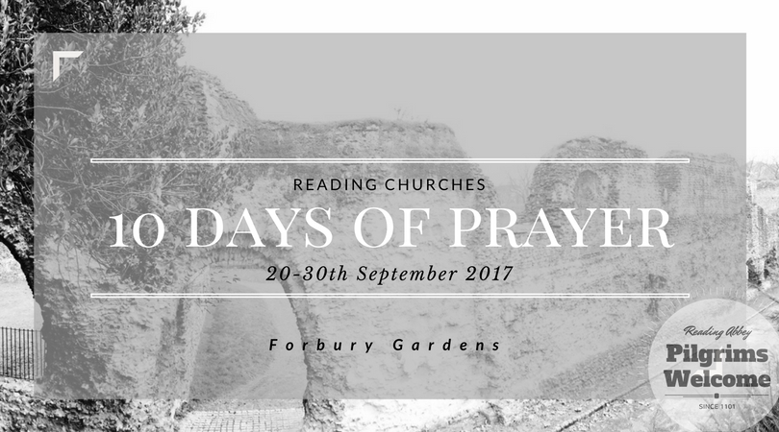

What Is 10 Days of Prayer?

This is an opportunity for those that are called by His name to gather round a cross and pray. There will be a Big Top tent in Forbury Gardens, designed to represent a portable Abbey Space. While the Abbey renovations take place nearby, this is our time to renovate the temple, a time to be in His presence, a time for holiness. Ten Days of Prayer is about TESHUVA . That’s usually translated as ‘repent’ but Teshuva means a lot more ─ It’s about Turning. Turning away from our ways and seeking God’s face. Seeking God’s face can be a conversation with God and that can be quite creative. We expect Prayer, Worship and Celebration to be a part of that conversation. It is an opportunity to come together and meet with God. After all He promises

*[1]If My people who are called by My name will humble themselves, and pray and seek My face, and turn from their wicked ways, then I will hear from heaven, and will forgive their sin and heal their land. (2 Chronicles 7:14)*

Don’t miss the beginning of this verse … IT STARTS WITH **IF** ─ it is an invite

You are invited to 10 DAYS OF PRAYER.

|  |
| --- |
| **Imagine if your town stopped for 10 Days to seek God’s face …**  **Imagine if YOU, YOUR CHURCH, YOUR TOWN  stopped for 10 Days to seek God’s face …**  **IF …** |

## How to find out more

10 Days of Prayer has a [website with more details](https://sites.google.com/view/10daysreading/home) and a [Facebook page](https://www.facebook.com/10daysreading/) to keep you up to date with the current news

When is 10 Days of Prayer?

The event will run from the 20th to the 30th of September 2017 in the Reading Abbey Grounds where pilgrims once gathered for hundreds of years. While the Abbey is restored we thought we’d celebrate by restoring the temple too. That’s those who are called by His name of course!

## Volunteering for 10 Days of Prayer

We are a tiny team so WITHOUT a small army of volunteers we cannot put this event on ─ we would love to partner with you.

To find out more about volunteering [please see this page on our website](https://sites.google.com/view/10daysreading/volunteering?authuser=0)

About the organisers.

10 Days of Prayer is a team of likeminded Christians with a passion to see Reading and the nation blessed, safe and prosperous . They have come together with the blessing of Bishop Andrew of Reading, Churches Together in Reading and RCN (Reading Christian Network www.readingchristiannetwork.com/ ) who are a network of churches who meet weekly for prayer and to build and sustain relationships together. 10 Days also has the important blessing of the two churches that border Forbury Gardens, St.Laurence Church and St. James & St William of York Church.

## Promotional Materials

We would really appreciate you telling your churches about this event.

Promotional documents (flyers, this document in Word & PDF formats) can be [found here](https://drive.google.com/drive/folders/0B4q5YDj0qJfoNmloMG1LZDlCTmM) for your use.

Bless you we look forward to meeting you as we seek our Father together!

1. *2 C 7:14 Jeremiah 18:7-8 gives a similar reassurance for all Nations if they choose to Teshuva.*

  